**WEEK 7**

12. ReactJS-HOL

Create a React Application named “ticketbookingapp” where the guest user can browse the page where the flight details are displayed whereas the logged in user only can book tickets.

App.js

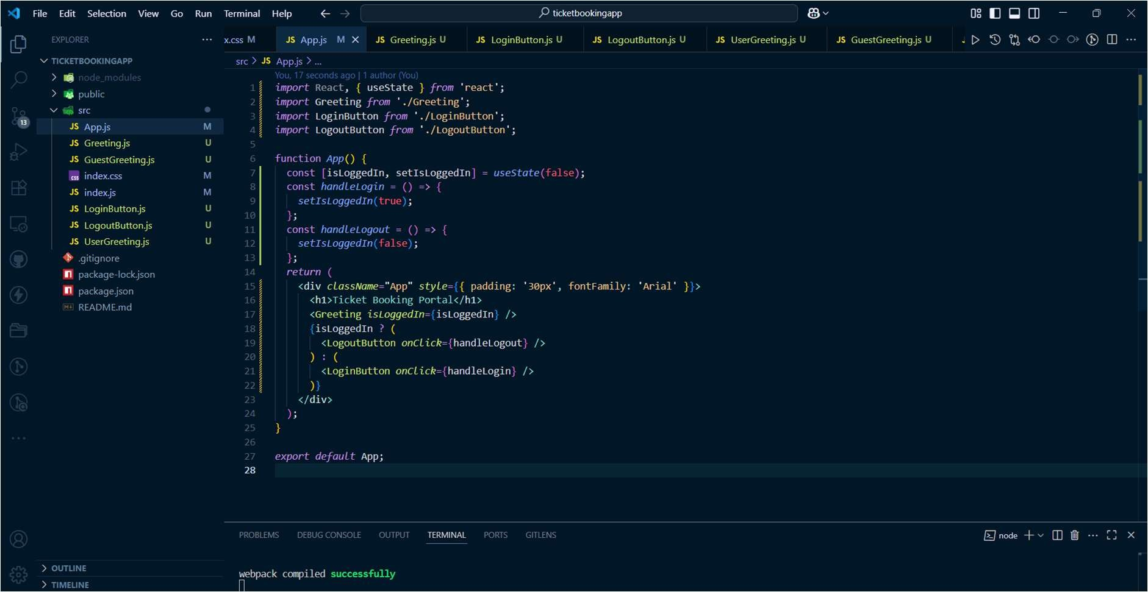

Greeting.js

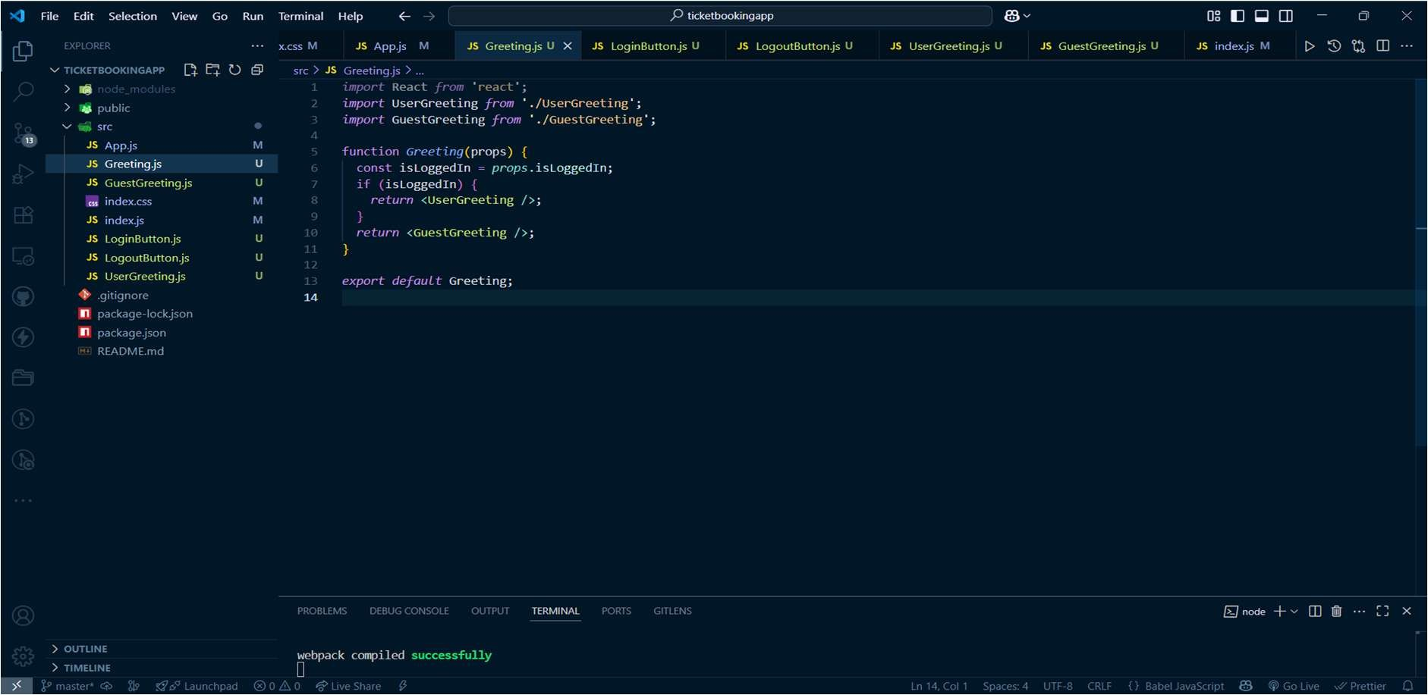

GuestGreeting.js

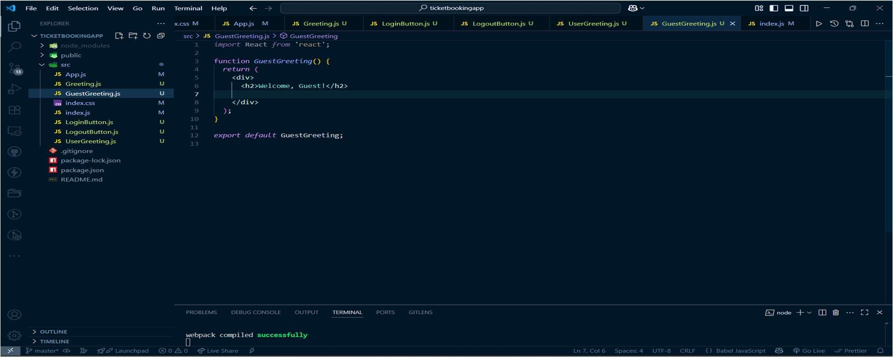

LoginButton.js

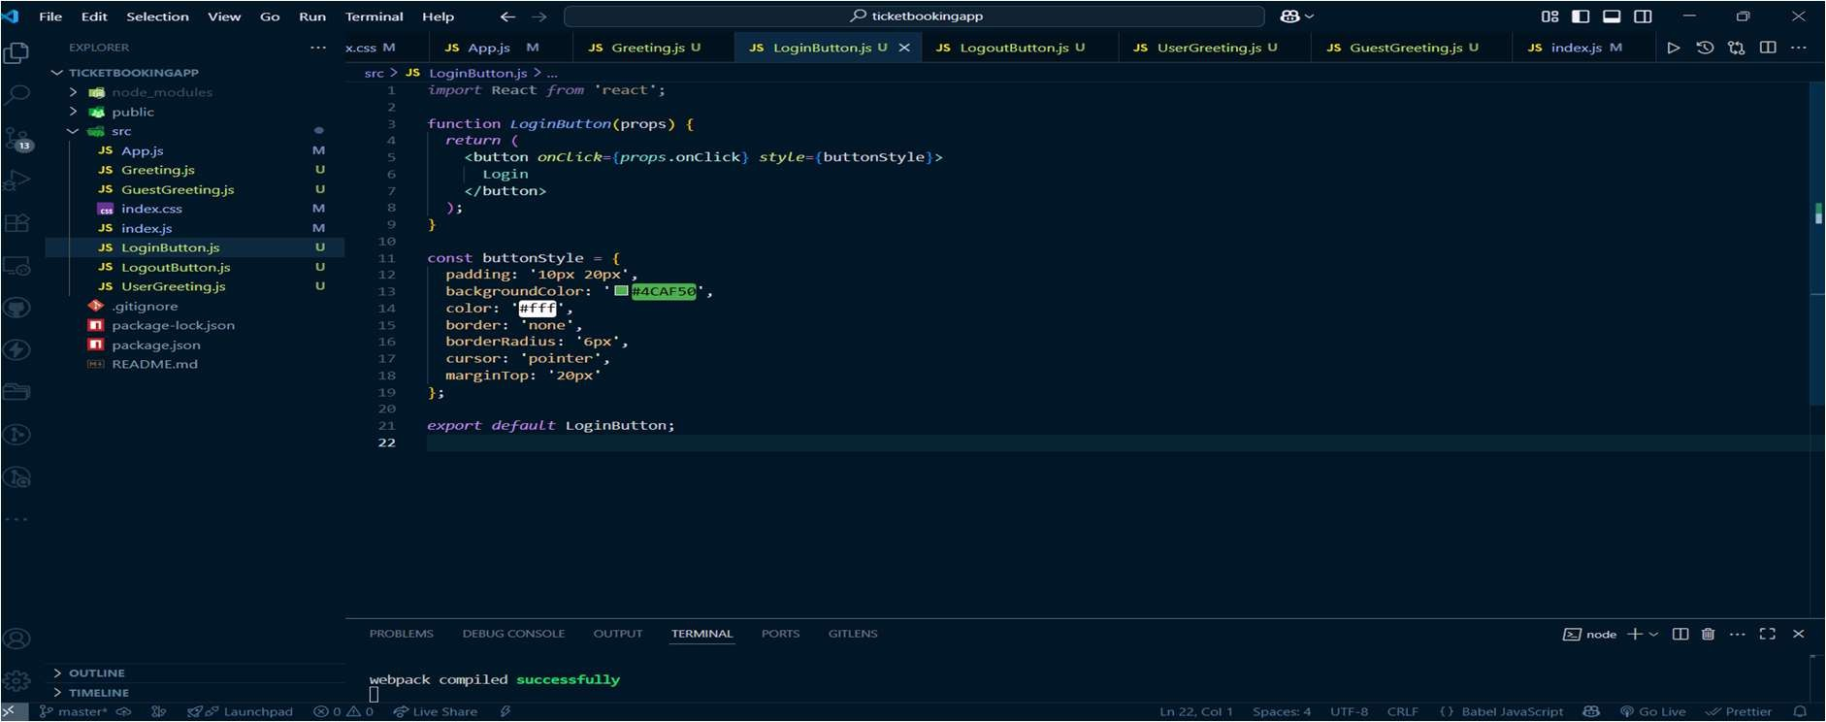

LogoutButton.js

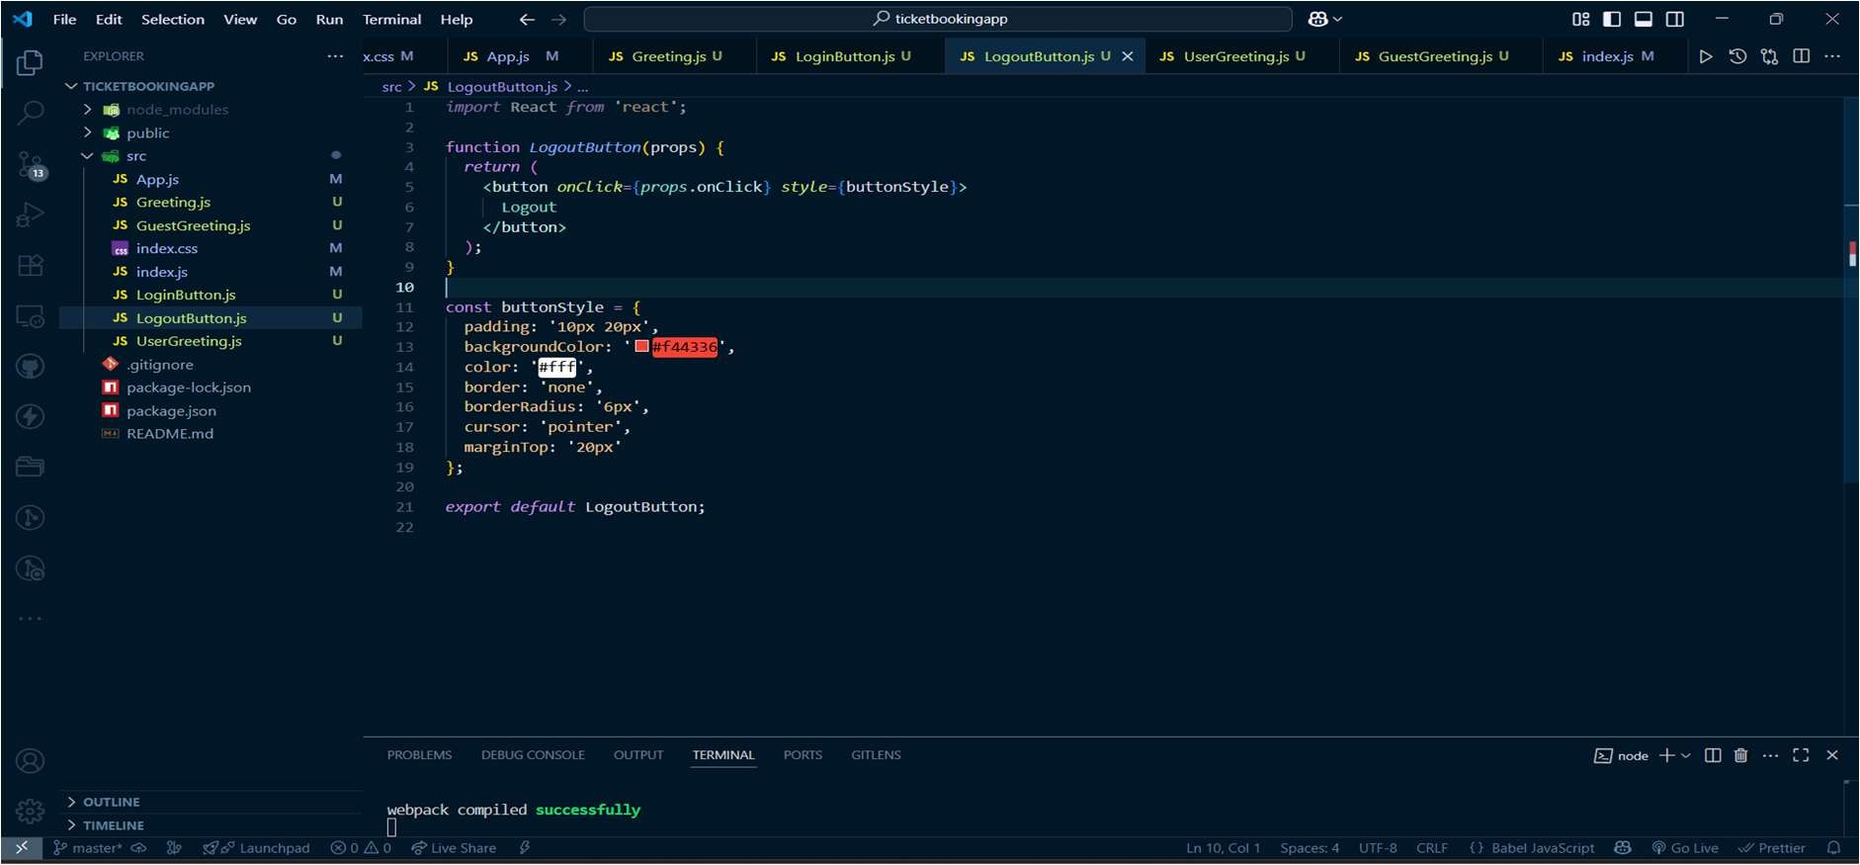

UserGreetings.js

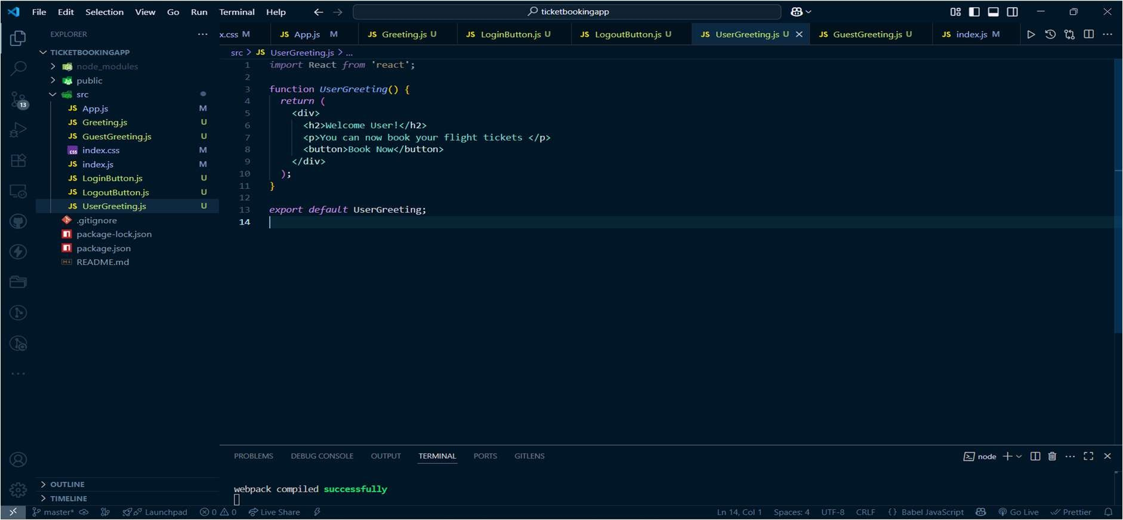

Output

